

***CONTAINERS AND DOCKERS***

***Submitted by:***

***NAME: Tanishqua Tellakula***

***SAP ID: 500084269***

***Roll number :R120220007***

***Batch: B1(Hons)***

***Lab Exercise 8- Creating and Managing a ReplicaSet in Kubernetes***

***Objective:***

*A ReplicaSet in Kubernetes ensures a specified number of Pod replicas are running at any given time. This exercise will guide you through creating a ReplicaSet to maintain the desired state of your application.*

* *Understand the syntax and structure of a Kubernetes ReplicaSet definition file (YAML).*
* *Learn how to create and manage a ReplicaSet to ensure application availability.*
* *Understand how a ReplicaSet helps in scaling applications and maintaining desired states.*

***Prerequisites***

* *Kubernetes Cluster: Have a running Kubernetes cluster (locally using Minikube or kind, or a cloud-based service).*
* *kubectl: Install and configure kubectl to interact with your Kubernetes cluster.*
* *Basic Knowledge of YAML: Familiarity with YAML format will be helpful for understanding Kubernetes resource definitions.*

***Step-by-Step Guide***

***Step 1: Understanding ReplicaSet***

*A ReplicaSet ensures a specified number of Pod replicas are running at any given time. If a Pod crashes or is deleted, the ReplicaSet creates a new one to meet the defined number of replicas. This helps maintain application availability and ensures that your application can handle increased load by distributing traffic among multiple Pods.*

***Step 2: Create a ReplicaSet***

*We'll define a ReplicaSet to maintain three replicas of a simple Nginx web server Pod.*

*Create a YAML file named nginx-replicaset.yaml with the following content:*

|  |
| --- |
| ***: apps/v1 # Specifies the API version used.***  ***kind: ReplicaSet # The type of resource being defined; here, it's a ReplicaSet.***  ***metadata:***  ***name: nginx-replicaset # The name of the ReplicaSet.***  ***spec:***  ***replicas: 3 # The desired number of Pod replicas.***  ***selector:***  ***matchLabels: # Criteria to identify Pods managed by this ReplicaSet.***  ***app: nginx # The label that should match Pods.***  ***template: # The Pod template for creating new Pods.***  ***metadata:***  ***labels:***  ***app: nginx # Labels applied to Pods created by this ReplicaSet.***  ***spec:***  ***containers:***  ***- name: nginx # Name of the container within the Pod.***  ***image: nginx:latest # Docker image to use for the container.***  ***ports:***  ***- containerPort: 80 # The port the container exposes.*** |

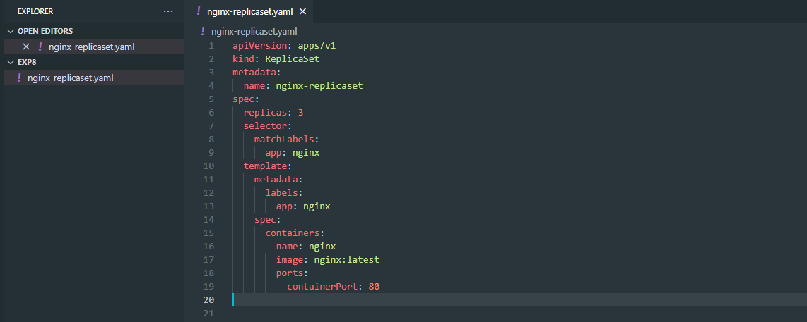

***Explanation:***

* *apiVersion: Defines the API version (apps/v1) used for the ReplicaSet resource.*
* *kind: Specifies that this resource is a ReplicaSet.*
* *metadata: Contains metadata about the ReplicaSet, including name.*
  + *name: The unique name for the ReplicaSet.*
* *spec: Provides the specification for the ReplicaSet.*
  + *replicas: Defines the desired number of Pod replicas.*
  + *selector: Criteria for selecting Pods managed by this ReplicaSet.*
    - *matchLabels: Labels that Pods must have to be managed by this ReplicaSet.*
  + *template: Defines the Pod template used for creating new Pods.*
    - *metadata: Contains metadata for the Pods, including labels.*
      * *labels: Labels applied to Pods created by this ReplicaSet.*
  + *spec: Specification for the Pods.*
    - *containers: Lists the containers that will run in the Pod.*
      * *name: The unique name of the container within the Pod.*
      * *image: The Docker image used for the container.*
      * *ports: Ports exposed by the container.*

***Step 3: Apply the YAML to Create the ReplicaSet***

* *Use the kubectl apply command to create the ReplicaSet based on the YAML file.*

|  |
| --- |
| kubectl apply -f nginx-replicaset.yaml |



***Verify the ReplicaSet is running and maintaining the desired number of replicas:***

|  |
| --- |
| ***kubectl get replicaset*** |

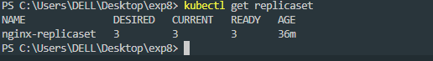

*This command lists all ReplicaSets in the current namespace.*

***To check the Pods created by the ReplicaSet:***

|  |
| --- |
| ***kubectl get pods -l app=nginx*** |

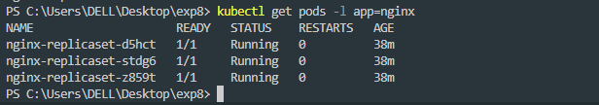

*This command lists all Pods with the label app=nginx.*

***Step 4: Managing the ReplicaSet***

***1. Scaling the ReplicaSet***

*You can scale the number of replicas managed by the ReplicaSet using the kubectl scale command.*

|  |
| --- |
| *kubectl scale --replicas=5 replicaset/nginx-replicaset* |



*This command scales the ReplicaSet to maintain 5 replicas. Verify the scaling operation:*

|  |
| --- |
| ***kubectl get pods -l app=nginx*** |

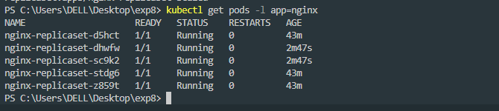

*You should see that the number of Pods has increased to 5.*

***2. Updating the ReplicaSet***

*If you need to update the Pod template (e.g., to use a different Docker image version), modify the YAML file and apply it again. For instance, change the image to a specific version of Nginx:*

|  |
| --- |
| ***spec:***  ***template:***  ***spec:***  ***containers:***  ***- name: nginx***  ***image: nginx:1.19.3 # Change to a specific version*** |

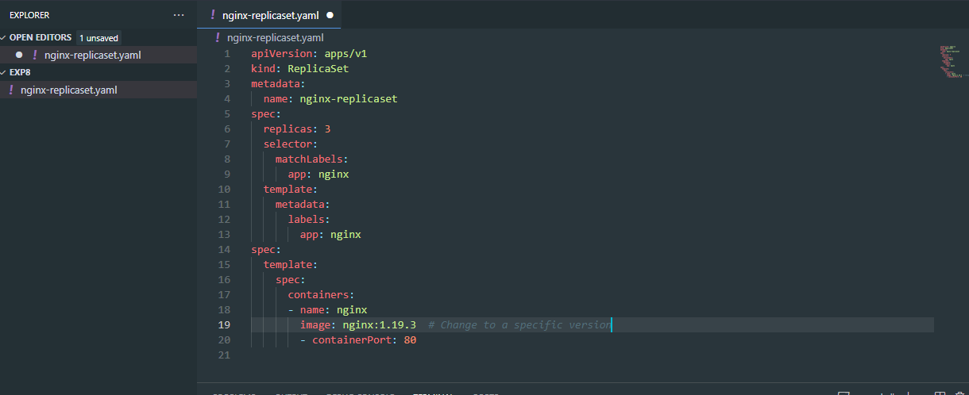

***Apply the changes:***

|  |
| --- |
| ***kubectl apply -f nginx-replicaset.yaml*** |



***Check the status to ensure the Pods are updated:***

|  |
| --- |
| ***kubectl get pods -l app=nginx*** |

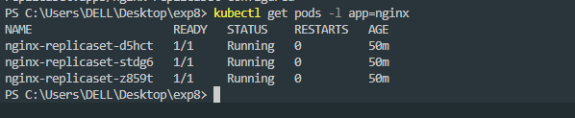

*Note: Updating a ReplicaSet doesn't automatically replace existing Pods with new ones. In practice, you often create a new ReplicaSet or Deployment for updates.*

***3. Deleting the ReplicaSet***

*To clean up the ReplicaSet and its Pods, use the kubectl delete command:*

|  |
| --- |
| ***kubectl delete -f nginx-replicaset.yaml*** |



*This command deletes the ReplicaSet and all the Pods managed by it.*